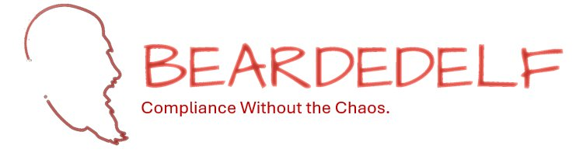 | eric@beardedelf.us  www.beardedelf.us

A Compliance Automation Add-On Your CMMC Clients Actually Need.
BeardedELF automates the ongoing compliance monitoring and evidence collection that defense contractors are required to maintain under CMMC Level 2. Add it to your service stack, differentiate your offering, and build recurring revenue — without building the automation yourself.
The Opportunity

Your defense contractor clients are dealing with a compliance calendar that never stops — weekly vulnerability reviews, monthly account audits, quarterly Assessment Objective checks, and an annual self-assessment with a DoD-reported SPRS score. Most are doing this manually, inconsistently, or not at all.

BeardedELF gives you a ready-to-deploy automation suite that handles this work for them. You bring the client relationship and the managed service wrapper. BeardedELF provides the automation, the documentation, and the evidence structure that makes CMMC compliance manageable.

What You Add to Your Service Stack

Product 1  Maintenance Checklist Automation Suite  Weekly, monthly, quarterly, bi-annual, and annual automation scripts covering 46 checklist items. Saves clients 321.5 hours of manual compliance work annually.  7 weekly scripts — vulnerabilities, audit logs, devices  2 monthly scripts — software inventory, accounts  Quarterly, bi-annual & annual scripts  Master Checklist and Tracking Dashboard included  Call to discuss pricing |  | Product 2  Ongoing Monitoring Suite  Assessment Objective-level evidence collection across 320 AOs — Quarterly, Bi-Annual, and Annual. Directly supports your clients' annual SPRS score reporting obligation to the DoD.  13 Quarterly AOs automated  5 Bi-Annual AOs automated  10 Annual AOs automated  Evidence structured to mirror C3PAO assessment methodology  Call to discuss pricing

Combined Bundle — Both Products: Call to discuss pricing
Retail value: $500/month per client — 400+ hours saved annually — complete CMMC compliance coverage

Why It Works for Your Practice

Recurring Revenue  Bundle BeardedELF into your managed service offering and bill it as a monthly line item. One deployment per client, monthly recurring revenue for the life of the engagement.  Stickier Client Relationships  Clients running BeardedELF have automated compliance infrastructure tied to their environment. That's not easy to walk away from — and it keeps you as the trusted partner managing it. |  | CCA-Developed Credibility  Developed by a Certified CMMC Assessor who has implemented GCC-High enclaves and taken clients through successful C3PAO Assessments. You're offering clients something built by someone who has sat on both sides of the assessment table.  Deployment Ready in 2-4 Weeks  Complete deployment documentation, client-agnostic templates, and 10 hours of included onboarding support per client. Your team deploys, BeardedELF runs, your client stays compliant.

How the Partnership Works

Referral Model  Introduce clients to BeardedELF directly. BeardedELF contracts with the client. You receive a referral fee of 15-20% of the first year subscription. | Reseller Model  Purchase BeardedELF at wholesale pricing and bundle it into your managed service offering. You set the client price and manage the relationship. | Getting Started  Reach out to discuss which model fits your practice. A Marketing Authorization Agreement is ready to execute. First deployment can begin within days.

BeardedELF LLC | eric@beardedelf.us | www.beardedelf.us | Compliance Without the Chaos.

